**Introduction to ERC-3643**

**ERC-3643** is an open-source **smart contract framework** for creating regulatory-compliant, permissioned digital securities on Ethereum or compatible blockchains (Polygon, Avalanche, etc.).

It is primarily used for **tokenization** of:

* Real estate
* Stocks
* Bonds
* Private equity

Unlike ERC-20 or ERC-721, ERC-3643 integrates **identity verification** (KYC/AML) and **compliance** directly into the token's logic, making it suitable for **regulated financial environments** like the **UK's Financial Conduct Authority (FCA)** requirements.

**Key Features of ERC-3643**

* Identity verification (KYC, AML, accredited investor checks)
* Permissioned transfers (only allowed between verified parties)
* Compliance with regulations (transfer restrictions by country, investor type, etc.)
* Recovery mechanisms for lost wallets
* Forced transfers under legal orders
* Full on-chain identity management

**Core Smart Contracts in ERC-3643 Framework**

|  |  |
| --- | --- |
| **Smart Contract** | **Purpose** |
| Identity Registry | Links wallet addresses to verified investor identities |
| IdentityRegistryStorage | Secure storage of KYC and identity data |
| Trusted Issuers | Approved KYC providers who issue identity claims |
| ClaimTopicsRegistry | List of required claims (e.g., "KYC passed") |
| Compliance | Enforces transfer and holding rules |
| Token (T-REX Token) | Represents the digitalized security asset |
| Agent Roles/Ownership | Manages token agents and contract ownership |

Optional:

* ModularCompliance (plug-in compliance rules)
* TokenLockup (enforce lock-in periods)
* ForceTransfer (regulatory enforcements)
* TokenRecovery (wallet loss recovery)

**ERC-3643 Workflow Overview**

**1. Identity Verification Phase**

* An investor submits KYC documents.
* A **TrustedIssuer** verifies and stores claims about the investor.
* Investor's wallet is whitelisted in **IdentityRegistry**.

**2. Token Issuance Phase**

* Issuer mints T-REX Tokens.
* Tokens are assigned to verified investors.

**3. Compliance Enforcement Phase**

* Each token transfer triggers **Compliance** checks:
  + Is sender KYC verified?
  + Is receiver KYC verified?
  + Are country, investor status, and holding limits satisfied?
* If all checks pass, transfer is allowed.

**Detailed Flowchart Diagram**

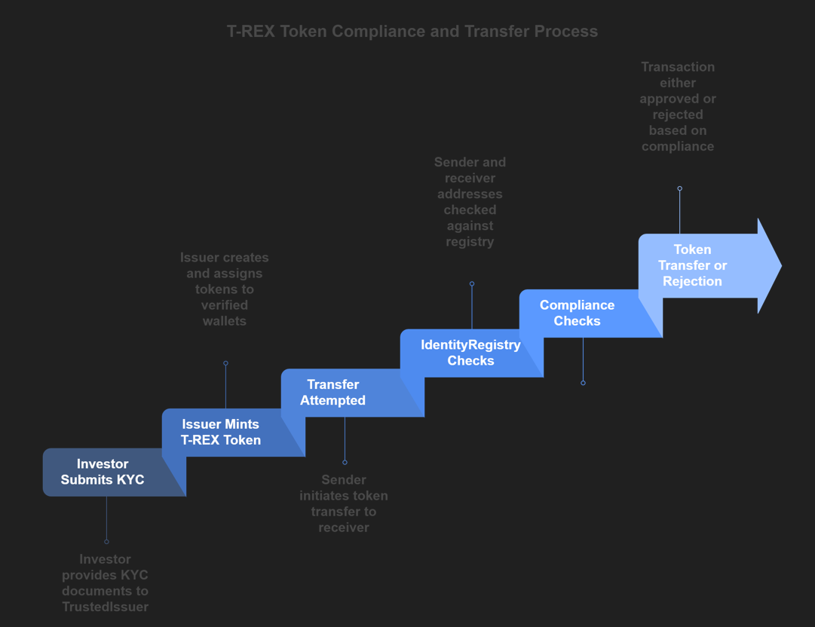

**How ERC-3643 Works for Digital Tokenization in the UK**

**Compliance with UK Law**

* **FCA guidelines** require investor KYC/AML and strict transfer controls.
* ERC-3643 enables digital assets to behave like traditional securities.
* Issuers can freeze, revoke, and forcibly transfer tokens based on UK court orders.
* Full audit trails are maintained on-chain.

**Real-world Example (Real Estate Tokenization)**

* A UK-based real estate firm tokenizes an apartment building worth £20 million.
* 20,000 T-REX tokens are minted (each token = £1,000 worth).
* Only KYC-verified UK/EU investors can buy or sell tokens.
* Compliance module checks that no investor holds more than 10% of total supply (per FCA rules).

**Benefits for the UK Market**

* Faster fundraising
* Broader investor reach
* Increased liquidity in secondary markets
* Full regulatory compliance

**Visual Architecture (ERC-3643 System)**

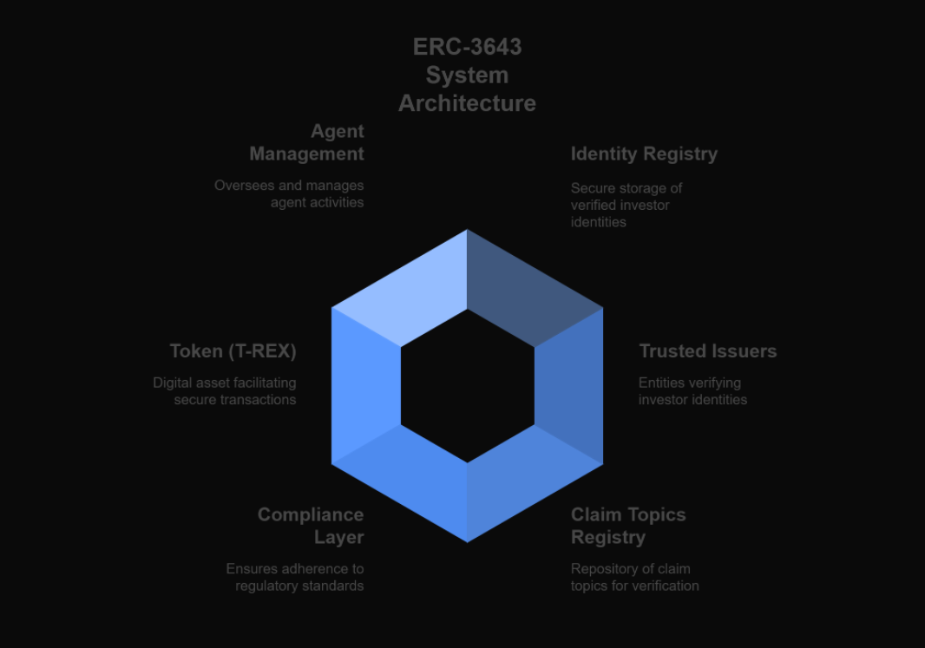

**Conclusion**

**ERC-3643** brings traditional finance compliance to blockchain-based assets. It's especially useful in countries like the **UK**, where regulatory scrutiny is high for digital securities.

Using ERC-3643, businesses can tokenize real estate, stocks, or bonds legally, safely, and efficiently, creating a new era of compliant digital ownership.

**Notes**

* Open-source libraries like OpenZeppelin support ERC-3643.
* Major platforms adopting ERC-3643: Tokeny, Polymath.
* ERC-3643 is also compatible with L2 solutions for scalability